# Our story

**Operations Manager**

**Glasgow ARBD**

**Enquiries to: Fiona Semple at fiona.semple@penumbra.org.uk**

We are **Penumbra Mental Health**, a pioneering charity providing dedicated services for people with mild to serious and enduring mental ill health.

We support people on their journey to better mental health, by working with each person to find their own way forward. The power of people’s lived experience enables us to deliver pioneering services which transform lives.

From being there for people in crisis to suicide prevention, supported living to self-harm management and peer support. We are with those we support every step of their journey to a better place. People's experiences are at the centre of everything that we do. **We champion peer workers**; they know that recovery is possible, because they’ve been there too.

Of course, **everyone’s journey is different**, so we work with people to identify, believe in, and reach their goals, whatever they may be. Often, it’s about hope, but we know that’s not always easy for people to hold on to. And so, when times are tough, we hold it for them, keeping it safe - just until the time is right.

You see, Penumbra has always been about people; listening and learning, challenging, encouraging and enabling. It’s why we’re trusted to provide services across Scotland, supporting thousands of people every month, because when people need us, we’re there.

**Our vision** is that people live with positive mental wellbeing and can easily access the best support when they need it.

**Our mission** is to provide exceptional mental health and wellbeing support and activities, guided by people’s own lived experience, their recovery journeys and their hopes and aspirations.

**We live and breathe our values**

* Compassion: we will listen and respond with hope, kindness and respect
* Courage: we will do the right thing, standing up got people, their rights, wellbeing and recovery
* Curiosity: we will explore, reflect, learn and adapt to create solutions that are best for people’s wellbeing
* Collaboration: we will work with those who share our vision and values

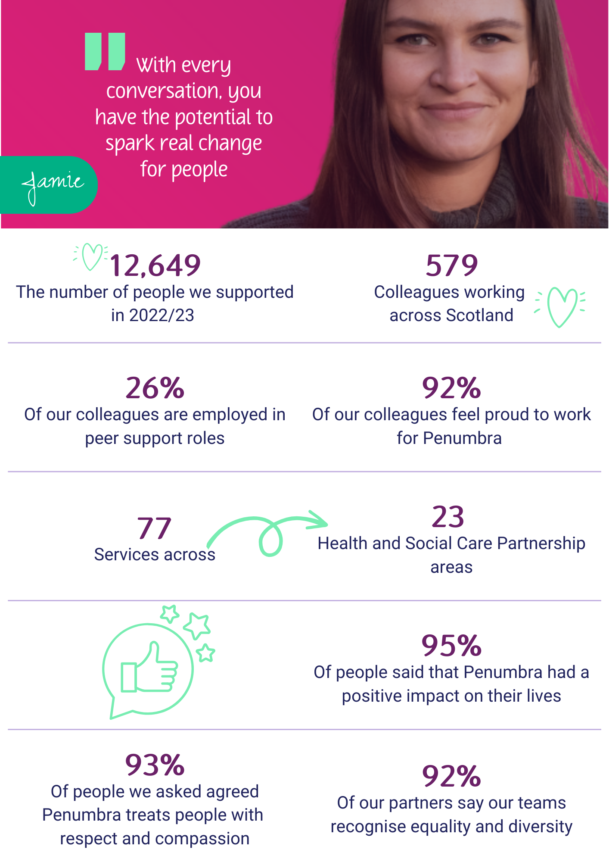

# Welcome

## Want to spark real change?

First of all, thank you for being interested in joining the Penumbra Mental Health team. We pride ourselves on being a great place to work where colleagues have space to grow and thrive. And we’re always looking for kind people like you who share our values and who want to spark real change.

You might already be working in a supporting role and looking to expand your skills into mental health recovery, or you might be looking for a new challenge altogether. Maybe you’re looking for a career where you can use your lived and living experience to support others on their journey (did you know 26% of our colleagues are employed in peer roles?).

Whatever your career or life experience, you’re in the right place if you want to make a difference and build your working life around meaningful connections with people who will inspire you every single day. Our promise to you? We can offer you a salary above the living wage, a tonne of employee benefits, and space to grow your skills and qualifications in a supportive and creative team. Don’t just take our word for it, click on the images below to hear from our colleagues, Jamie, Martin, Nick and Jodi.

We know that applying for a new role can be daunting. That’s why we encourage applications from everyone even if you’re not sure if you meet all the person specifications. What’s important to us are your values, kindness, willingness to learn, and your passion for quality mental health support.

We hope you find everything you need in this application pack. If you have any questions, you might want to check out our [careers page](http://www.penumbra.org.uk/careers) where you’ll find some FAQs and interview tips.

](https://youtu.be/tVDc4TdeDWs?si=O3mdDdqalaNJ0u2H)

](https://youtu.be/XJ2FjqZbjdA) [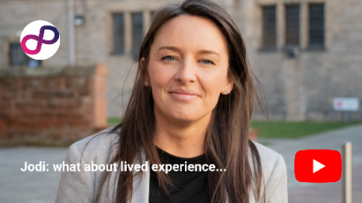](https://youtu.be/C94S7J-A3io)

# Advertisement

## Operations Manager

## Location: Possilpark, Glasgow

## Salary: £38,324 - £41,305 per annum (£19.65 - £21.18 p/h equivalent)

## Full Time – Permanent

If you are looking for a rewarding career and to work within an epic team that will help you grow and thrive, then you have come to the right place. Working within our Glasgow ARBD service you can start your day knowing what you do really does make a difference!

At Penumbra, we strive to create a culture and environment where people feel valued and inspired to reach their own personal goals. Our fundamental priority is to provide support which is safe and promotes recovery, social inclusion, and citizenship for people with mental health challenges.

We recognise that the people we support have skills and experience that can bring about positive changes for themselves. Through an ethos of inclusion, equality and fairness, our staff are committed to promoting good mental health and wellbeing for people using our services.

Our ARBD supported accommodation is based in Bardowie Street in Glasgow’s Possilpark and is an assessment centre for people who have been diagnosed with ARBD or possible ARBD. We provide a safe and positive environment in which people can develop the life skills and confidence to actively move towards and define their recovery.

The service provides bespoke and proactive support to identify and address the individual’s needs, placing them at the heart of their support. With an emphasis on independence and empowerment, people are helped to move toward self-identified goals. While there is an element of collaborative group work, this is at all times focused on improving self-esteem and addressing issues such loneliness, social exclusion, and addiction in a supportive peer environment.

As a mental health charity, we really value the wellbeing of our staff. That’s why we want you to know that you’ll be joining a friendly team, who will give you a supportive environment to help you thrive in your role, including all the training you need to feel confident and equipped.

We can offer you a tonne of employee benefits, and we can promise you’ll be inspired by some pretty amazing humans every single day. We will support you on your own career path; developing new skills, accessing formal and informal learning experiences and providing opportunities to put your continual progress into practice.

# Job Description

## Operations Manager

|  |  |
| --- | --- |
| **Service:** | Glasgow ARBD |
| **Supervisory duties:** | Mental Health & Wellbeing Practitioners & Team Leader |
| **Responsible to:** | Senior Operations Manager |
| **Salary:** | £38,324 - £41,305 per annum – point 34-37 |
| **Working hours:** | 37.5 hours per week |
| **Location:** | Possilpark, Glasgow |
| **Closing:** | Sunday 14th September at 7pm |
| **Interview:** | Week commencing Monday 22nd September |
| **Special condition:** | Local Travel, Pager duties on rotation. |

|  |
| --- |
|  |

## Job summary:

To provide operational management and direction to all staff within their area of responsibility and to demonstrate a wider leadership role across Penumbra services within your remit. To support the implementation of the delivery plan for services and programmes within your remit, supporting delivery of the overarching organisational strategy. To be responsible for the compliant and safe delivery of high-quality support services and build a culture that aligns to our values and a positive leadership approach. Integral to this is the development of person-centered and recovery-focused services with people which supports them to achieve their personal outcomes and live a satisfying, hopeful and contributing life.

|  |
| --- |
|  |

## Competencies

### Skill

**Education**

* Willing to work towards SVQ4 in Adult Health and Social Care and an SVQ4 in Leadership and Management in Social Care, or equivalent professional qualification at SCQF Level 9 or above.

**Experience**

* Experience in mental health support developing and implementing adapted structured support plans for people with a range of mental health issues.
* Demonstrative experience applying established methods and systems effectively in managing a caseload, coordinating care for supported people including through participation of multi-disciplinary teams.
* Experience contributing to the ongoing development and improvement of service management, processes and approaches that improve overall service delivery.

**Knowledge**

* In-depth working knowledge of recovery-focused mental health support tools and approaches and ability to adapt to meet the differing needs of supported people with a range of needs.
* Knowledge of the voluntary sector and the commissioning and regulatory environment in which we work.
* Knowledge of Social Care and the implementation of policies and procedures to improve service delivery and the outcomes for supported people..
* In-depth knowledge of mental health support tools, such as recovery models and structured intervention techniques, with the ability to adapt these tools to the differing needs of supported people.
* Proficiency in the use of electronic record keeping and referral management systems including the ability to troubleshoot issues and optimise use.

### Responsibility

**Fiscal responsibility**

* Responsible for managing a service level budget and ensuring all financial records are accurately maintained and reported to the relevant people as per Penumbra financial policies and procedures.
* Working with Regional and Programme Managers to ensure the effective deployment of resources (human, physical, financial) to deliver agreed outcomes, identify shortfalls and make recommendations for corrective action, taking forward as directed

**Supervisory responsibility**

* Provide line management support to direct reports within your sphere of responsibility and other services/programmes where necessary.
* Provide guidance and support to your team, helping them navigate complex cases and improve service delivery.
* Participate in the pager system to support colleagues across your region/programme..
* Ensure the effective management and development of all staff within line management remit.
* Work to embed a coaching culture within your area of responsibility that upholds the values of Penumbra.
* Demonstrate positive leadership and provide direction to your team(s).

**Decision-making**

* Decide on the most suitable recovery tools and interventions to use with supported people, based on their personal support plan and progress, while ensuring these align with Penumbra’s approaches.
* Working with the Senior Operations Managerl/Programme Manager set targets within your service(s) to ensure the effective delivery of portfolio plans at regional and service level.
* Exercise judgement in balancing the competing demands of the service need and resource constraints ensuring all service activity is based on contractual and business need and is in line with the regional/programme plan. Use sound judgement when deciding about the use of resources in order to deliver key objectives within the required timescale and achivement of quality.
* Ensure the design and delivery of services is based on recognised good practice and in line with Penumbra’s recovery focussed approaches and values.
* Influence and contribute to the design, delivery and implementation of bespoke interventions and services to drive positive change for individuals and communities.

**Compliance**

* Ensure compliance with all external regulatory and contractual responsibilities; provide timeous information on activity and achievements to identified stakeholders and ensure action is taken to address areas of concern.
* Support the establishment of and ensure use of effective methods to review and improve service performance, with a specific focus upon achieveing contractual and operational obligations (Local Authority, Care Inspectorate, Health and safety etc) within your service(s)
* Develop and review service plans to deliver in line with the delivery plan.
* Monitor risks associated with the delivery of services in your portfolio and take the appropriate action when needed.

### Effort

**Mental effort**

* Often working under pressure and balancing multiple demands in complex/changing environments.
* Lead managers and staff through complex and challenging cases adjusting your approach wne needed.
* Developing and implementing solutions to challenges encountered durnig service delivery, such as adjusting group dynamics in a session based on client interactions.
* Analysing support data and feedback to adapt support plans or interventions, ensuring they align with Penumbra approaches and recovery models.

**Physical effort**

* Daily requirement for sitting/inputting at keyboard for a significant part of the working day, with appropriate breaks from VDU when required.
* Move between different locations and environments within their area of responsibility to provide supervision and attend meetings.

**Focus and concentration**

* The ability to make sound judgements, deal with interruptions and meet tight deadlines.
* Balance the needs of meeting high quality standards, staff performance and supervision and the everchanging needs of the services within your area of responsibility.
* Prolonged concentration and attention to detail required daily, for instance in ensuring consistency and attention to detail in client records, preparing reports or managing rota’s despite frequent interruptions.
* Ensure high levels of awareness and participation in local networks in support of Penumbra’s business strategy and ambitions.
* Analysis of often complex service data and feedback to ensure alignment with Penumbra’s recovery focussed approaches, and, in partnership with Senior Operations manager/Programme Manager, to agree reporting expectations, producing reports as agreed for internal and external reporting.

**Emotional effort**

* Maintain positive leadership and resilience when dealing with colleagues and stakeholders whilst manintaining professionalism and compassion.
* Provide operational support to your teams during periods of change or significant crisis.

**Flexibility and adaptability**

* Support staff to adapt and change approach to meet the changing needs of their services, teams, stakeholders and supported people.
* Adjust workload to meet the ever changing demands placed on the role enduring the approach remains effective and appropriate.
* Develop local relatonships in the pursuance of service development and improvements, and Penumbra’s Strategic and Business objectives
* Manintain good and proactive retaltionships with key stakeholders in line with service requirements eg contract and commissioning managers; HSCP staff; Scottish Government.

### Working Conditions

**Environmental conditions**

* Performing tasks in diverse environments in Penumbra and external offices with key stakeholders.
* Envrironments may vary in terms of noise and lighting.

**Hazards**

* May involve hazzards navigating public spaces when working outside of the office.
* May involve unexpected situations when working in co-located spaces such as spills and fire alarms.

**Work schedule**

* The work may require a high degree of flexibility and may extend beyond standard business hours. This will include managing the on call pager.
* The work will involve a regular schedule and travel within your area of responsibility.

**Stress**

* Lead challenging meetings providing emotional support to colleagues and teams after stressful events.
* Monitoring the stress levels of the Team Leaders and staff teams to improve their wellbeing offering support when needed.
* Maintain resiliance whilst under pressure to maintain a calm presence for the team during crisis situations.

**Travel requirements**

* Regular travel within the area of responsibility attending internal and external meetings.
* May be required to attend meetings at Penumbra’s head office in Edinburgh.

## Behaviours

|  |  |
| --- | --- |
| **Taking Responsibility** | **Take ownership of your work and use your initiative to deliver your objectives and role expectations. Be accountable for your own performance and development by taking responsibility for your actions and decisions.** |
| **Building Trust and Respect** | **Recognise the importance of self awareness and the impact you have on others. Value difference, diversity and inclusion, ensuring fairness and opportunity for all. Be open and listen carefully to the views and opinions of others. Build relationships based on trust, respect, compassion and kindness.** |
| **Working Together** | **Form effective partnerships and relationships with people internally and externally from a range of diverse backgrounds. Work with others to reach a common goal; sharing information, supporting colleagues and seeking expertise, ideas and solutions from others where needed. Actively listen and take on board the views and opinions of others.** |
| **Excellence** | **Seek out opportunities to harness diverse views, talents and ways of thinking among staff and stakeholder groups to create effective change and suggest innovative ideas for improvement. Review ways of working, including seeking and providing feedback to improve services. Demonstrate a can-do and professional attitude.** |
| **Keeping it Simple** | **Communicate clearly and concisely, to ensure the message is understood by all. Actively work to prevent overcomplication or confusion, demonstrating a clear, simple, non-bureaucratic approach to work.** |

# Conditions and Remuneration

## Salary Package

£38,324 - £41,305 per annum

## Holiday

33 days per annum including public holidays, plus an extra day for each years’ service, rising up to 38 days after 5 years’ service.

## Pension

5% employer pension contribution (salary sacrifice). Also offer auto-enrolment pension scheme.

## Benefits

* Flexible working.
* Cycle to work scheme.
* Confidential Employee Assistance Programme.
* Employee Discount Scheme with Vivup – 100’s of lifestyle savings.
* Payroll Pay with Vivup – pay monthly available across a variety of options including home & electronics, discounted gym memberships and more.
* Death in Service benefits.
* Full training and professional development.
* Refer a friend scheme – earn up to £400.
* Salary sacrifice pension.
* Additional day of annual leave for each year of service, up to 5 days of annual leave after 5 years of service.

And so much more!

# Get in touch

If you’d like an informal chat about this role and working for Penumbra Mental Health, please contact: Fiona Semple at [Fiona.semple@penumbra.org.uk](mailto:Fiona.semple@penumbra.org.uk).

For more on our who we are visit: [penumbra.org.uk](http://www.penumbra.org.uk/journeys)

For more opportunities across our teams visit: [penumbra.org.uk/careers](http://www.penumbra.org.uk/careers)

# Application & Interview Guidance

We know applying for jobs and preparing for interviews can be daunting – but we really want you to enjoy the process. It’s a chance for you to showcase all of your skills and learn more about what we do at Penumbra. Everyone is really friendly, and we want your application to be a success!

That’s why we have put together these tips, so you know what to include in your application and what to expect at interview.

Penumbra is committed to supporting candidates with disabilities, neurodiverse candidates, and candidates with mental health conditions throughout the recruitment process. We will make any reasonable adjustments required to ensure a fair and inclusive process for all. If you think you require reasonable adjustments, please don’t hesitate to contact us at [recruitment@penumbra.org.uk](mailto:recruitment@penumbra.org.uk).

## Application

The application stage allows you tell us about all the great skills and experience you’ve got to offer, and how they’ll help you in the role you have applied for.

In your personal statement, we are looking for the skills outlined in the competencies in the person specification section of this pack. Tell us about a time when you’ve developed or demonstrated these skills – this could be from your work life or personal life. Using the STAR method outlined below will help to structure your points.

This is also a great opportunity to tell us about your passion for mental health, and remember if you’re applying for a peer role, tell us about your lived experience and how you think you could utilise it in the role!

## Interview

The interview stage is a chance for us to meet you, and for you to learn more about Penumbra or ask any questions you might have. What will be included in the interview might vary between roles and services (for example, some may include written questions) but this will be explained to you ahead of time.

All of our interviews include competency-based questions. Competency Based questions aim to find out how you have used specific skills in your previous experience and how you approach problems, tasks and challenges.

The competency based questions will be on each of the competencies outlined in the person specification of this pack. We would recommend preparing a few examples of times you have demonstrated each of these competencies in advance. When answering the questions, you should try to stick to the STAR method, outlined below.

## STAR Method

The STAR method can be used to structure your answer to the competency-based questions you’ll be asked – it helps you to make sure you get all of the important points across. It breaks an answer down into 4 parts:

|  |  |
| --- | --- |
| **S**ituation – | What was the situation you had to deal with? |
| **T**ask – | What task were you presented with as a result of the situation? |
| **A**ction – | What action did you take? |
| **R**esult – | What was the result of this action, what did you learn from the result? |

Here’s an example of the STAR method in use:

## Question

Tell me about a time you had to deal with a conflict. How did you handle it?

## Answer

|  |  |
| --- | --- |
| **S**ituation | I was part of a team where one colleague was regularly late for our scheduled meetings, which was causing a lot of frustration amongst the rest of the team. |
| **T**ask | I knew it was important someone raised the issue with him in order to keep the team working well, so I took responsibility for handling it. |
| **A**ction | At the end of one of our regular meetings, I asked if he had a minute to catch up. I mentioned to him that he seemed stressed, and that he had been late to quite a few of our meetings and explained the impact it was having on the team. I expressed that we all really valued his input at the meetings, and asked if there was anything causing the lateness or if there was anything the team could do to support him. He shared that he was overwhelmed with his workload, and it was impacting his ability to manage his time. |
| **R**esult | By handling this conflict sensitively and in a supportive manner, we were able to identify what was causing the issue, and distribute some of our colleague’s extra workload amongst the team. This took the pressure off him and enabled him to manage his time more effectively. This in turn meant the team was able to work together more efficiently and we didn’t miss out on anyone’s input. |